**STATISTICS PROJECT**

Name: Priscilla Grace Rose Sugumar

Q1. Test for a one-way contingency table to confirm the race percentages with race codes=1, 2, 3 are 0.45,0.20 and 0.35, respectively. Compute p-value and draw statistical conclusion?

**Ans:**

Statistical Method Used**: Chi-Square Test**

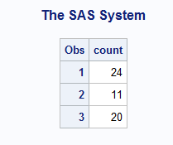

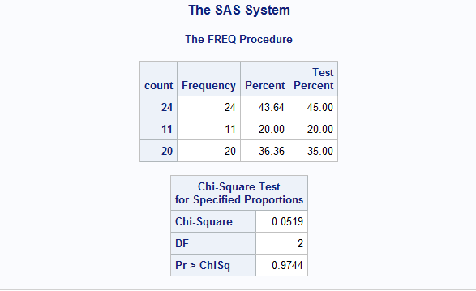

The data is tested with percentage 45,20,35 for the races 1,2, 3.

**Null Hypothesis** (H0), P1 = 45%, P2 = 20%, P3 =35%

**Alternate Hypothesis** (H1), P1 = 43.64%, P2 = 20%, P3 = 36.36%.

**DF = 2**

**Chi-Square value = 0.0519**

**P value = 0.9744.**

Since the alpha value is 0.05 and the P value is 0.9744ie.,greater than alpha we accept the null hypothesis.

Q2. Test for H0: *p*1 = *p*2 vs H1: *p*1 *̸*= *p*2, where *p*1 and *p*2 are proportions of female and male students.

Draw statistical conclusion?

**Ans:**

Statistical Method Used: **Chi-square test**

Consider P1 as male proportion and P2 as female proportion

|  |  |
| --- | --- |
| Null Hypothesis(H0) | P1 = P2 = 0.5 |
| Alternate Hypothesis (H1) | P1 ≠ P2 |

Statistical Method Used: **Chi-square test**

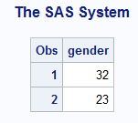

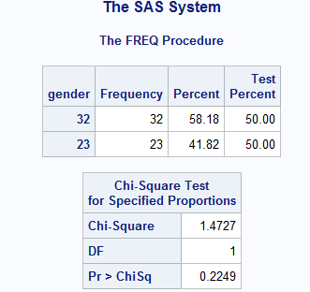

Degree of Freedom = 1

Chi-Square Value = 1.4727

P value = 0.2249

From the above statistical inference, it is found that P value **0.2249** is > than 0.05 so the null hypothesis H0 is accepted

Q3. Use the chi-square goodness-of-_t method without continuity correction to determine whether the

student reading scores are from the normal distribution *N* (47*:*8*;* 8*:*82). Divide data into 5 disjoint

categories: *≤* 40, *>* 40 and *≤* 46, *>* 46 and *≤* 48, *>* 48 and *≤* 52, and *>* 52. Report the degree

of freedom and the observed value of chi-square test statistic, p-value and draw statistical conclusion

based on your findings?

Null Hypothesis (H0): The scores of the students in reading section follow normal distribution.

Alternate Hypothesis (H1): The scores of the students in reading section does not follow normal distribution.

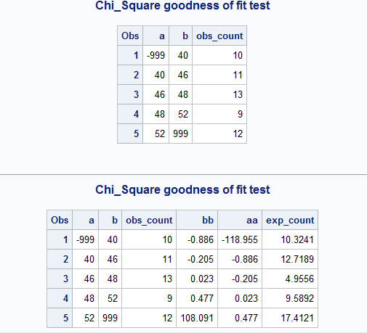

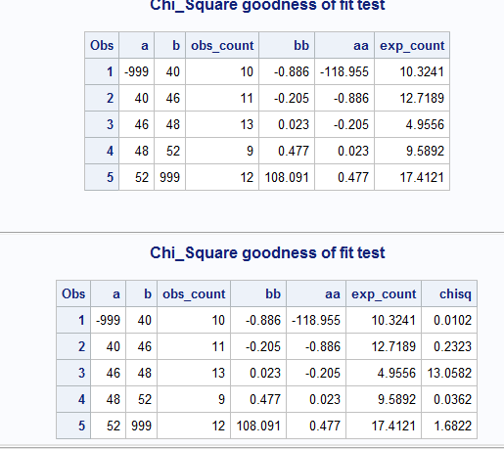

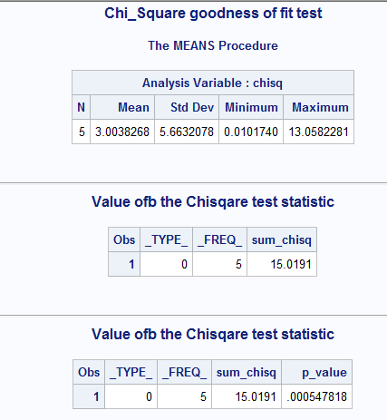

The Chi- square test value = 15.0191.

The degree of freedom is 2 and corresponding

p-value = 0.000547818 is less than alpha level of 0.05

Since the p value 0.000547818 is less than alpha level 0.05, Null hypothesis (H0) is rejected and therefore it indicates that the scores do not follow normal distribution. Hence alternate Hypothesis (H1) is accepted.

Q4. Determine an appropriate statistical method to compare mean test scores between male and female students for each of 5 courses, respectively. Describe the null and alternative hypotheses. Calculate 5 p-values and perform 2-sided tests to draw 5 conclusions?

**Ans:**

Statistical Method Used: **Wilcoxon Rank Sum Method**

**Reading:**

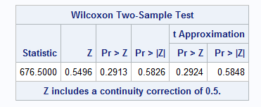

The p value is 0.5826 > than alpha 0.05

Therefore, Null Hypothesis (H0) is accepted. Thus, we conclude that the mean test scores between male and female students for Reading is equal.

**Writing:**

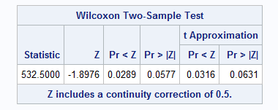

The p value is 0.0577 > alpha value 0.05.

Therefore, Null Hypothesis (H0) is accepted.

Hence the mean test scores between male and female students for Writing is equal.

**Math:**

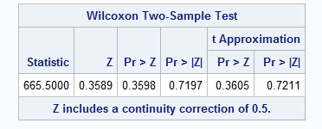

The p value is 0.7197 > alpha 0.05.

Therefore, Null Hypothesis (H0) is accepted.

So, the mean test scores between male and female students for Mathematics is equal.

**Science:**

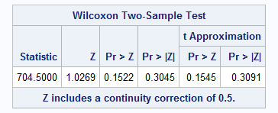

The p value is > alpha 0.05.

Therefore, Null Hypothesis (H0) is accepted.

Hence the mean test scores between male and female students for Science is equal.

**Social Science:**

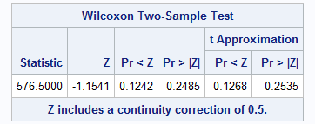

The p value is 0.2485 > Alpha 0.05.

Therefore, Null Hypothesis (H0) is accepted.

Hence the mean test scores between male and female students for Social Science is equal.

The two-sided p values of the five courses between male and female in the normal approximation are listed below,

|  |  |
| --- | --- |
| **Reading** | **0.5826** |
| **Writing** | **0.0577** |
| **Math** | **0.7197** |
| **Science** | **0.3045** |
| **Social Science** | **0.2485** |

From the above table we see that p values of the five courses are greater than alpha level 0.05. The null hypothesis (H0) is accepted. Therefore, the mean test scores of male and female are equal.

Q5. Select an appropriate statistical method to test for the equality between mathematics and science

scores, and the equality between writing and social science scores, but only for all female students.

Report the values of the observed test statistic for each of the two comparisons. Compute the two

p-values for your tests and draw two statistical conclusions?

**Ans:**

Null Hypothesis (H0): The mean test scores of Mathematics and Science are equal

Alternate Hypothesis (H1): The mean test scores of Mathematics and Science are not equal.

Statistical Method Used: **Wilcoxon Signed Rank Method**

**Math and Science:**

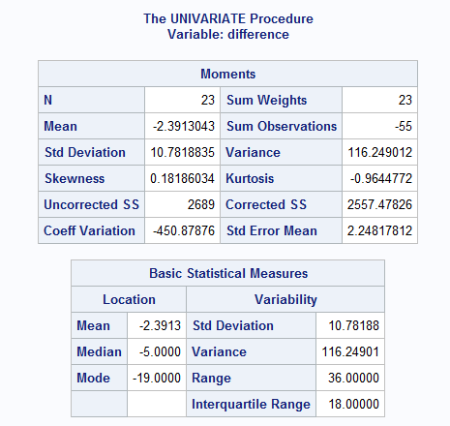

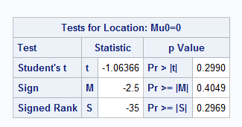

p value for Math and Science is 0.2969

The p value > alpha 0.05. Therefore, Null Hypothesis H0 is accepted. Therefore, the mean test score of Mathematics and Science are equal.

**Writing and Social Science:**

Null Hypothesis (H0): The mean test scores of writing and social sciences are equal.

Alternate Hypothesis (H1): The mean test scores of writing and social sciences are not equal.

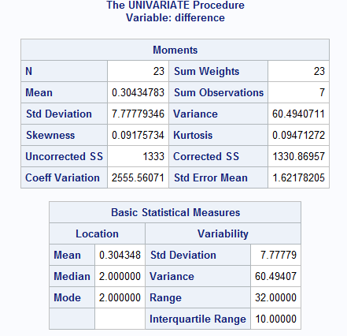

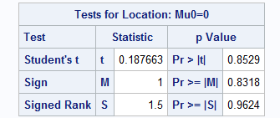

p value for writing and social science is 0.9624

The p value 0.9624 is > alpha value 0.05.

Therefore, Null Hypothesis H0 is accepted and the mean test scores of writing and social sciences are equal.